0.6 0.2 n=3

DP:

0.1808,0.1808,0.1809,0.1809,0.1809,0.1809,0.1809,0.1809,0.181,0.181,0.181,0.181,0.1811,0.1811,0.1811,0.1811,0.1811,0.1811,0.1811,0.1811,0.1811,0.1812,0.1812,0.1812,0.1811,0.1811,0.1812,0.1812,0.1812,0.1812,0.1812,0.1812,0.1812,0.1812

Random:

0.1573,0.1576,0.159,0.16,0.1613,0.1624,0.1639,0.1656,0.1668,0.1683,0.1699,0.171,0.1722,0.1732,0.1742,0.1749,0.176,0.1769,0.1779,0.1786,0.1795,0.1803,0.181,0.1815,0.182,0.1825,0.1828,0.183,0.1831,0.1834,0.1836,0.1838,0.184,0.184

SCS:

0.1814,0.1815,0.1815,0.1816,0.1815,0.1815,0.1815,0.1814,0.1814,0.1814,0.1813,0.1814,0.1814,0.1813,0.1814,0.1814,0.1814,0.1814,0.1814,0.1814,0.1815,0.1815,0.1815,0.1814,0.1814,0.1814,0.1814,0.1814,0.1814,0.1814,0.1814,0.1814,0.1814,0.1814

HR:

0.1828,0.1828,0.183,0.183,0.1832,0.1833,0.1834,0.1835,0.1836,0.1838,0.184,0.1841,0.1843,0.1843,0.1844,0.1845,0.1846,0.1848,0.1848,0.1849,0.1849,0.185,0.1851,0.1851,0.1851,0.1851,0.1853,0.1853,0.1854,0.1854,0.1855,0.1855,0.1855,0.1855

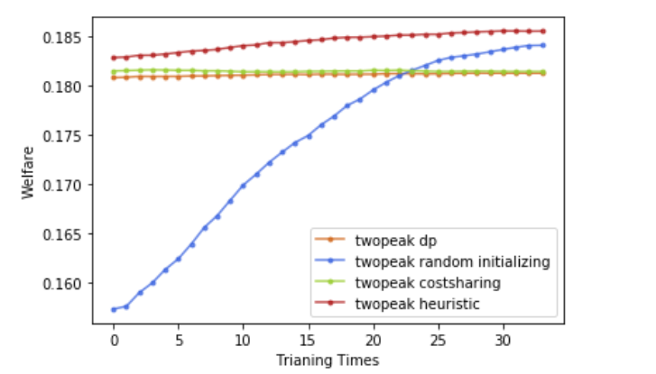

penalty 都为0